**Practical No. 5**

**Aim:** List of Basic Kali Linux Command.

1. Time and Date Command

This command is used to set the current date and time in the system. It is one of the basic kali linux commands.

In Kali Linux, the **'date'** command is used to display the **system date** and **time.**

**Syntax:**

**$date**

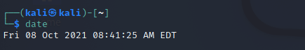

Setting your system time and time zone is usually done when initially [installing Kali](https://linuxconfig.org/how-to-install-kali-linux). If that step is skipped during installation, have switched time zones, or your system clock has drifted out of sync it could be done later as given below.

**Step 1:** First, in order to find out what time zone our system is presently configured for, we have to open the terminal and execute the following command.

**Syntax:**

**$ timedatectl**

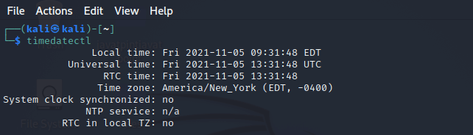

**Step2:** Next, with the help of the following command, we can get a list of accessible time zones. Choose one which is appropriate for our area and configure our system to that time zone in the next step.

**Syntax:**

**$ timedatectl list-timezones**

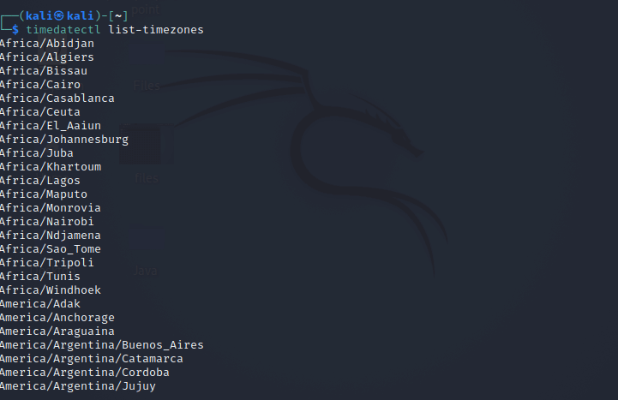

In order to narrow down the search, we can use the grep command. This command will provide a list of all possible time zones in Australia, as shown in the example below:

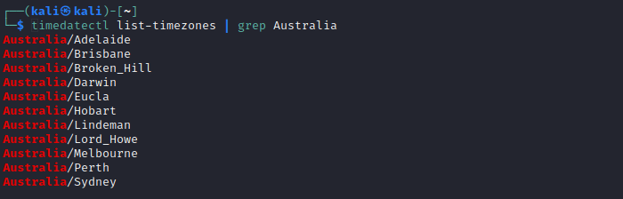

**Step 3:** We need to use the following syntax to set the system's time zone once we've selected the correct time zone from the list.\

**Syntax:**

**$ sudo timedatectl set-timezone Australia/Sydney**

**Step 4:** Use the **timedatectl** command to verify that the modifications have taken effect.

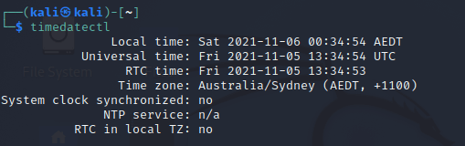

**Step 5:** We can use the following commands, in order to turn time synchronization on or off:

**Syntax:**

**$ sudotimedatectl set-ntp on**

OR

**$ sudotimedatectl set-ntp off**

**Step 6:** If we want to change the system clock to a certain date and time, make sure time synchronization is off (as described above) and use the following **date** command. This command will set the date and time to **05 November 2021, 08:42 PM,** but we can substitute any value which we want.

**Syntax:**

**$ sudo date -s "05 NOV 2021 08:42:00"**

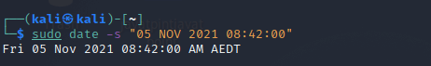

1. **Cal Command**

The cal command displays the current **month's formatted calendar** on our terminal screen. If we require a more advanced version of **cal,** we can install the **ncal package** on our Linux machine, which displays the calendar vertically and provides additional options.

**Syntax:**

**$ Cal**

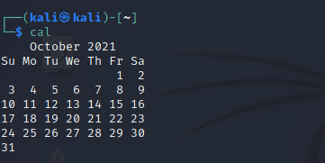

**$ cal -y**

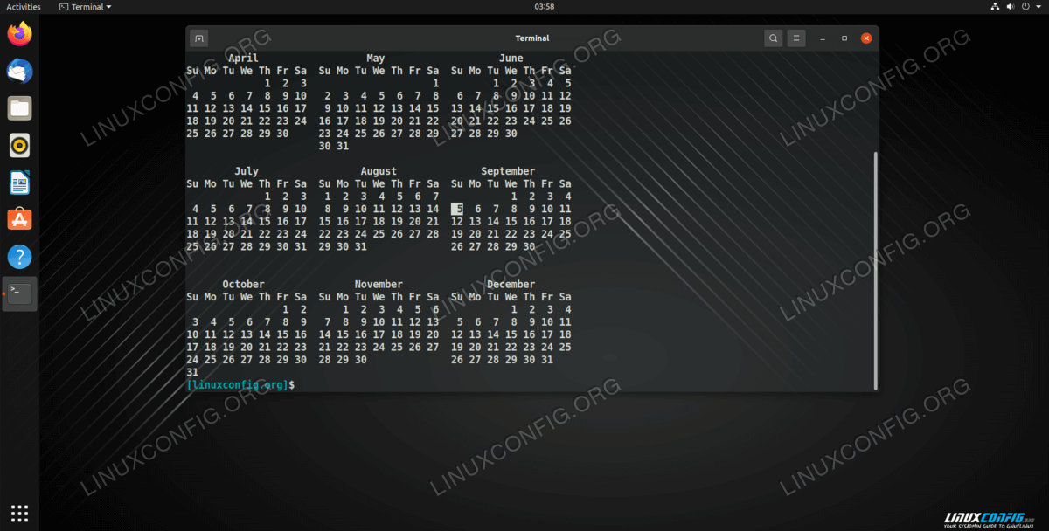

**$ cal 08 2019**

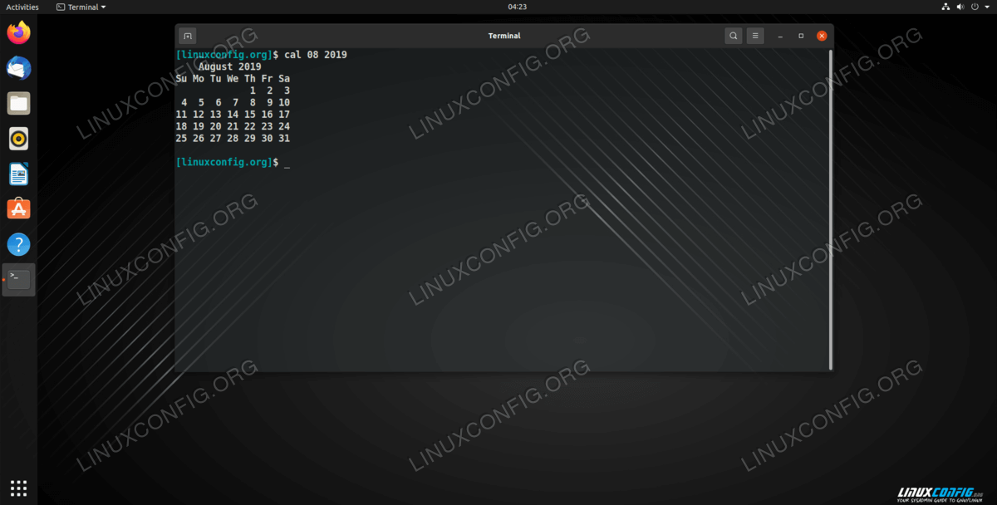

1. **Cd Command**

The **'cd'** command is also called **chdir** (Change Directory). We used this command to **change** or **switch** the current working directory.

**Syntax:**

**$cd Desktop**

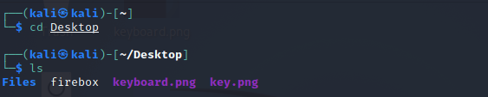

1. **cp Command**

In Kali Linux, the **'cp'** command is used to **copy** files or a group of files or directories that create an exact image of a file on a disk with a different file name.

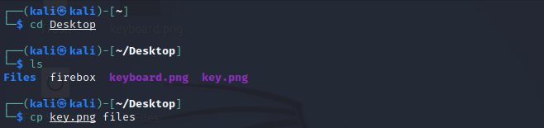

1. **whoami Command**

The **'whoami'** command is used to print the effective **user ID** whereas the **who** command prints information regarding users who are presently logged in.

The **"w"** command can also be used to view who is logged on and what they are doing.

**Syntax:**

**$whoami**

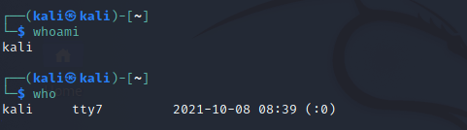

1. **Ls Command**

One of the most useful commands in Kali Linux is the **'ls'** command. The **ls** command lists the directory contents of files and directories. With the help of the **ls** command, we can easily list out every hidden file of a directory with the **-a** attribute, and for more detailed output, we can use the **-l** attribute.

**Syntax:**

**$ ls -al**

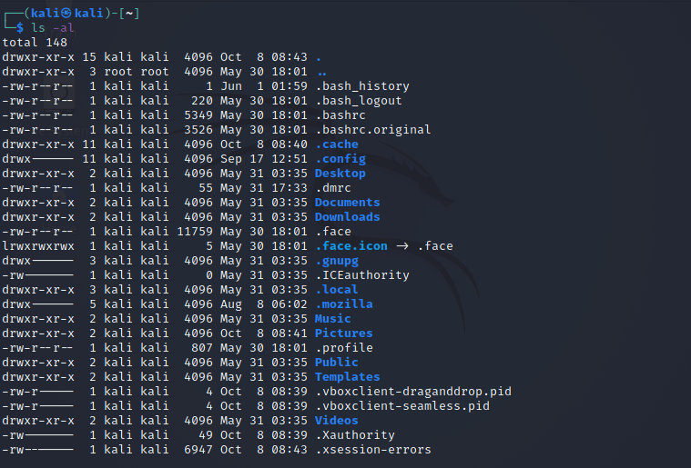

1. **Cat Command**

The **'cat'** (concatenate) command is one of Kali Linux's most commonly used commands, permitting us to create single or many files, concatenate files and redirect, view contain of file output in terminal or files.

Usually, we use the cat command to display the content of a file.

**Syntax:**

**$ cat filename**

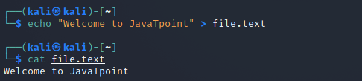

1. **mkdir Command**

The **'mkdir'** command is used to **create directories.** For example, if we wish to create a directory named **'Penetration testing'** under the **'Documents'** directory, then we have to open a terminal and enter the below command:

**Syntax:**

**$cd Documents**

**$mkdir Penetration testing**

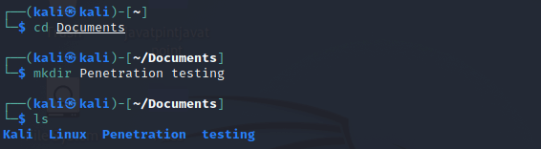

1. **rm Command**

In Kali Linux, the **'rm'** command is used to **delete files.** It can be used to delete directories when we use them recursively. The removal process separates a file name form its associated data in a file system and identifies that space in the storage device as available for future writes. In other words, when we erase a file. the data inside it remains unchanged, but it is no longer linked to a filename.

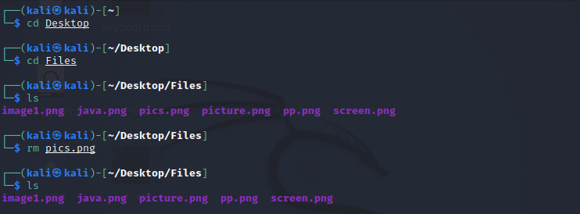

1. **mv Command**

With the help of the **'mv'** command, we can **move** or **renames** files and directories on our file system.

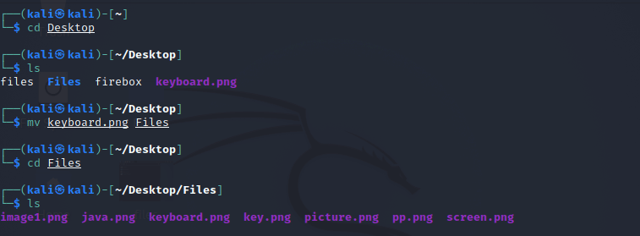

1. **uname Command**

The **'uname'** command displays the **current system's information.** We can view system information about our Linux environment with the uname command in Linux. With the **uname -a command,** we can learn more about our system, including **Kernel Name, Node Name, Kernel Release, Kernel Version, Hardware Platform, Processor,** and **Operating System.**

**Syntax:**

**$uname**

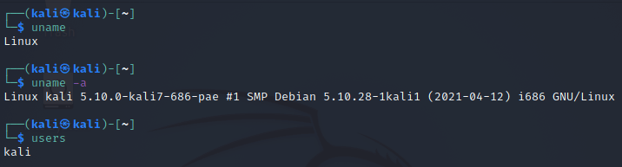

1. **uptime Command**

The **'uptime'** command displays the amount of time the system has been running. Uptime's basic usage is simple: simply **type** the name of the command and click **Enter.**

Use the **-p** command-line option if we merely want to know how long the system has been up for and in a more human-readable format.

**Syntax:**

**$ uptime**

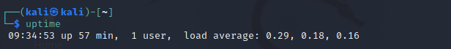

1. **users Command**

The **'users'** command is used to display the **login names** of users logged in on the system.

**Syntax:**

**$ users**

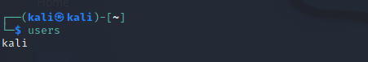

1. **vi Command**

The **'vi'** editor is a screen editor that comes with practically every **UNIX** system. The **command mode** and the **insert mode** are the two most common nodes in vi.

In order to start entering text in an empty file, we have to first switch from the command mode to the insert mode. To accomplish this, start typing the letter i. When we start typing, anything then the type will be entered into the file.

Type some short lines, then press Return at the end of each. **Vi** does not use word wrap like other word processors. It will break a line at the screen' edge. If we make a mistake, we can undo it by pressing the **Backspace** key. If the Backspace key on our computer is not working, then try the **ctrl + h** key combination.

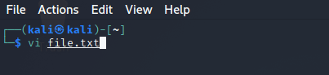

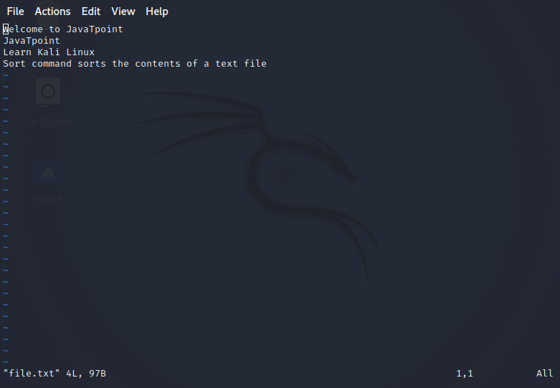

1. **free Command**

In Kali Linux, the **'free'** command provides us the useful information about the **amount of RAM** available on a Linux machine. It also displays the entire amount of **physical memory** used and available space, as well as **swap memory** with **kernel buffers.**

**Syntax:**

**$free**

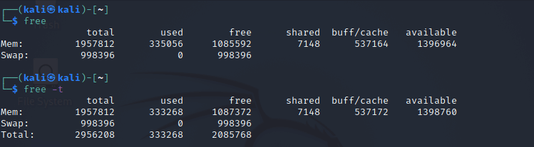

1. **sort Command**

Using the **'sort'** command, we can sort the content of the text file, line by line. Sort is a standard command-line program which prints the lines of its input or concentration of all files listed in its argument list in sorted order.

**Syntax:**

**$sort file name**

We can reverse the order of any file's contents by using the **-r** sort.

**$sort -r**

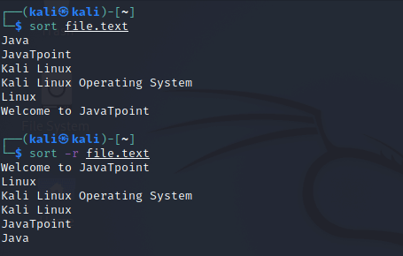

1. **history Command**

The **'history'** command is one of Kali Linux's most commonly used commands. The history command in the bash shell saves a history of commands entered that can be used to repeat commands.

We can run the history command by itself, and it will just print the **current user's bash history** on the screen, as shown below:

**Syntax:**

**$history**

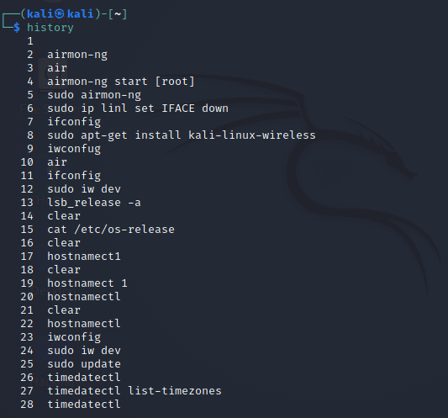

1. **Pwd Command**

In Kali Linux, the **'Pwd'** command is used to **print working directory.** It gives us information about the directory we are now in. This is especially useful if we need to access the directory while in the middle of a complicated process.

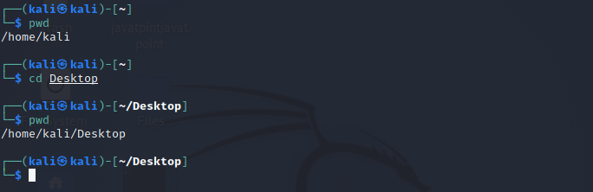

Conclusion: Thus we have studied the basic commands of kali linux.